03-02-2022

**//1 Write a program to input and print elemnts of Array**

#include<stdio.h>

int main()

{

int i,n;

printf("\n Enter The Total Numbers:");

scanf("%d",&n);

int arr[n];

printf("\n Start Entering The Number:");

for(i=0;i<n;i++)

{

scanf("%d",&arr[i]);

}

printf("\nnumbers entered are\n");

for(i=0;i<n;i++)

{

printf("%d\n",arr[i]);

}

return 0;

}

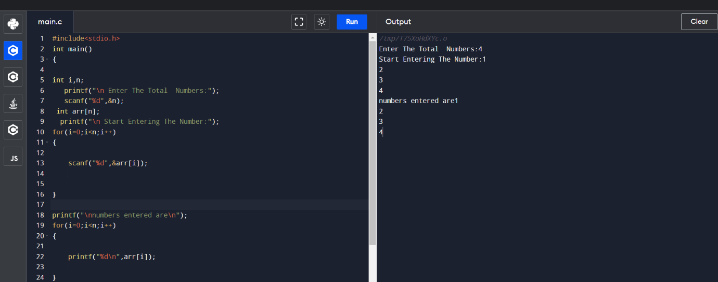

**2 write a Program to input numbers and print their sum and their avg.**

#include<stdio.h>

int main()

{

int i,n,sum=0;

printf("\n Enter The Total Numbers:");

scanf("%d",&n);

int arr[n];

printf("\n Start Entering The Number:");

for(i=0;i<n;i++)

{

scanf("%d",&arr[i]);

sum=sum+arr[i];

}

printf("\nnumbers entered are\n");

for(i=0;i<n;i++)

{

printf("%d\n",arr[i]);

}

printf("\nSum of enterd no %d\n",sum);

printf("\nAvg of enterd no %d\n",sum/n);

return 0;

}

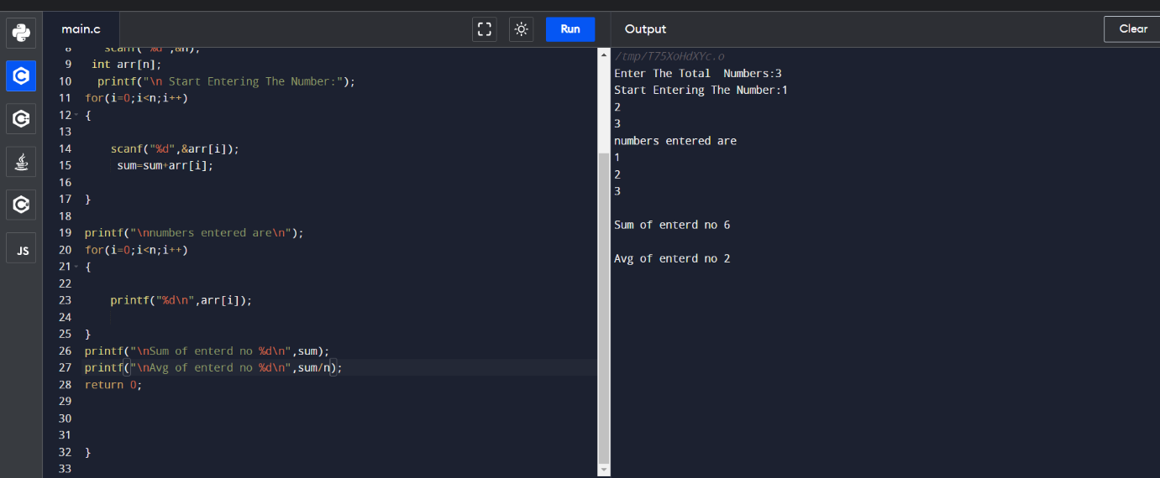

**//3Elemnt to find position of integer**

#include<stdio.h>

int main()

{

int i,n,sum=0,f,flag=0;

printf("\n Enter The Total Numbers:");

scanf("%d",&n);

int arr[n];

printf("\n Start Entering The Number:");

for(i=0;i<n;i++)

{

scanf("\n%d",&arr[i]);

}

printf("\nEnter number to search in given array \n");

scanf("\n%d",&f);

for(i=0;i<n;i++)

{

if(f==arr[i])

{

printf("position of number is :%d",++i);

flag=1;

break;

}

}

if (flag==0)

printf("Elemnt not found in arry");

return 0;

}

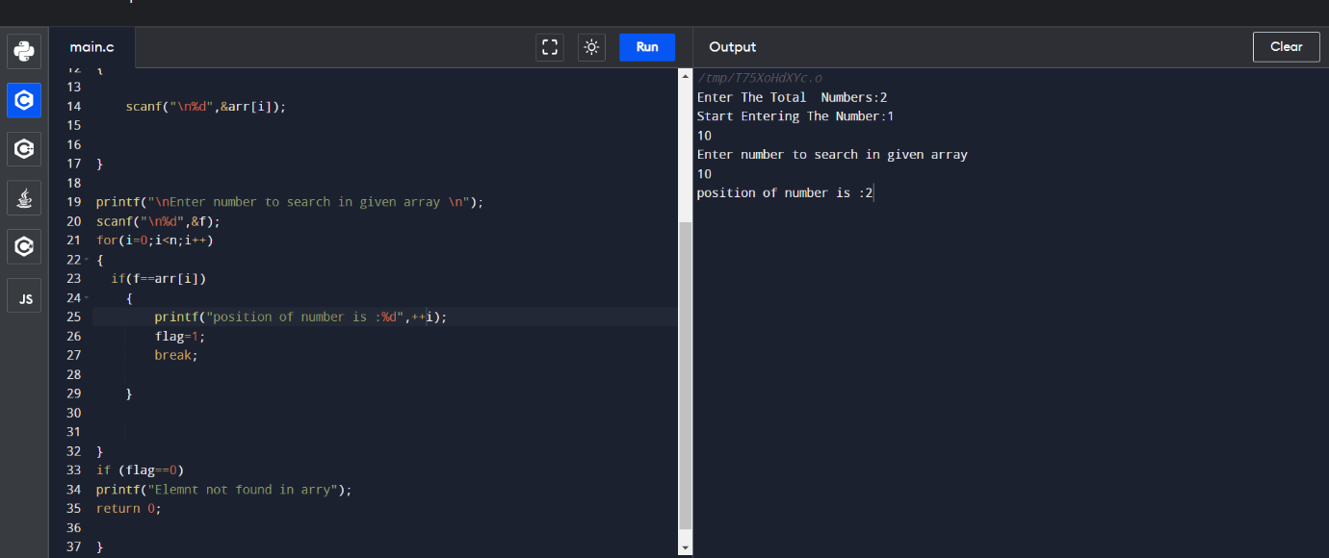

**4 C program to accept N numbers and arrange them in an ascending order**

#include <stdio.h>

void main()

{

int i, j, a, n, number[30];

printf("Enter the value of N \n");

scanf("%d", &n);

printf("Enter the numbers \n");

for (i = 0; i < n; ++i)

scanf("%d", &number[i]);

for (i = 0; i < n; ++i)

{

for (j = i + 1; j < n; ++j)

{

if (number[i] > number[j])

{

a = number[i];

number[i] = number[j];

number[j] = a;

}

}

}

printf("The numbers arranged in ascending order are given below \n");

for (i = 0; i < n; ++i)

printf("%d\n", number[i]);

}

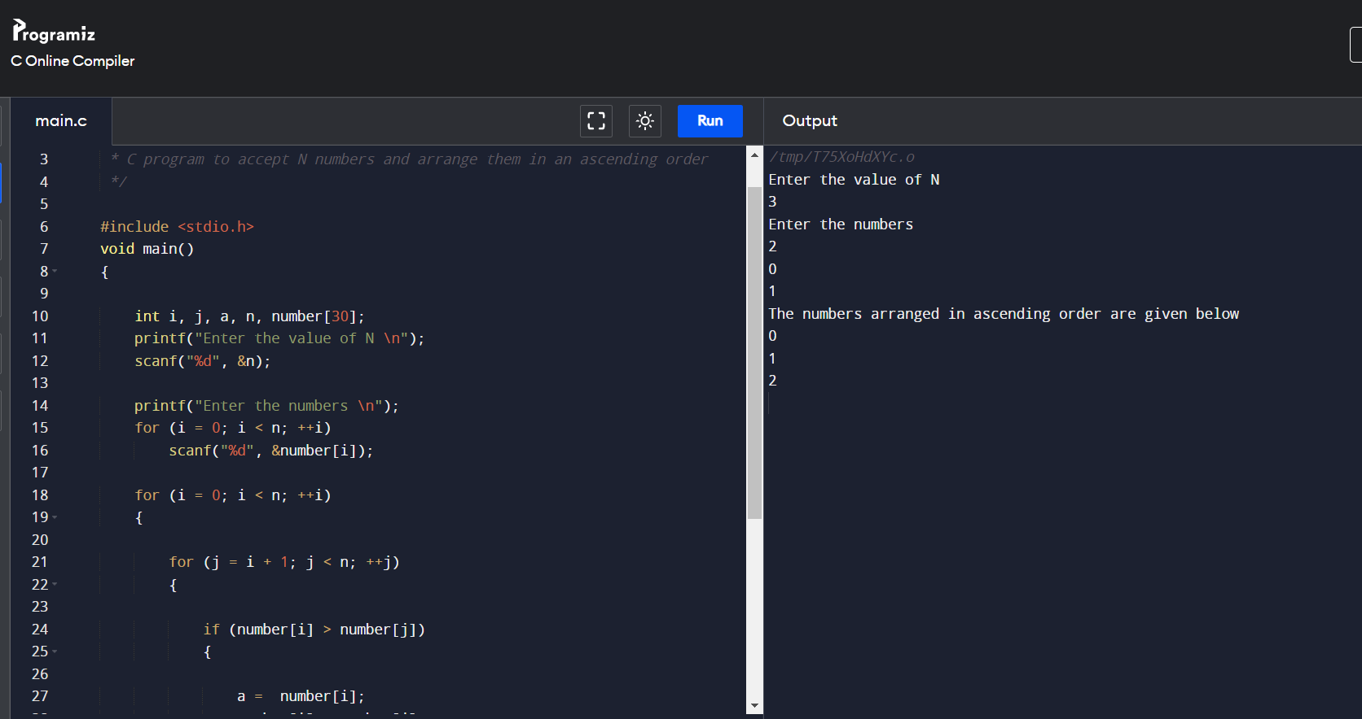

**5 C program to accept N numbers and arrange them in an ascending order**

/*

*

*/

#include <stdio.h>

void main()

{

int i, j, a, n, number[30];

printf("Enter the value of N \n");

scanf("%d", &n);

printf("Enter the numbers \n");

for (i = 0; i < n; ++i)

scanf("%d", &number[i]);

for (i = 0; i < n; ++i)

{

for (j = i + 1; j < n; ++j)

{

if (number[i] < number[j])

{

a = number[i];

number[i] = number[j];

number[j] = a;

}

}

}

printf("The numbers arranged in descending order are given below \n");

for (i = 0; i < n; ++i)

printf("%d\n", number[i]);

}

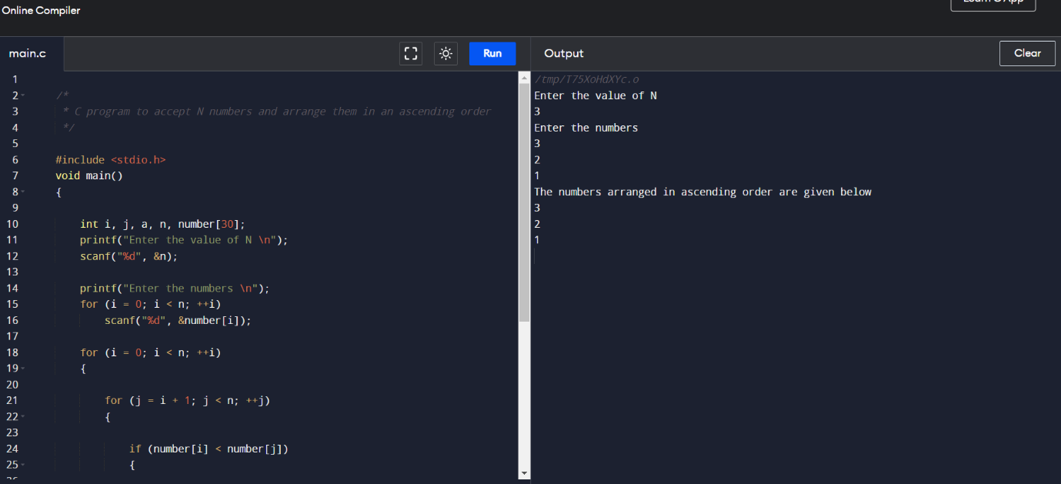

//6 odd count

/*

* C program to accept N numbers and arrange them in an ascending order

*/

#include <stdio.h>

void main()

{

int i, count, n, number[30];

printf("Enter the value of N \n");

scanf("%d", &n);

printf("Enter the numbers \n");

for (i = 0; i < n; ++i)

scanf("%d", &number[i]);

for (i = 0; i < n; ++i)

{

if (number[i]%2)

{

count++;

}

}

printf("The odd numbers count is \n");

printf("%d\n", count);

}

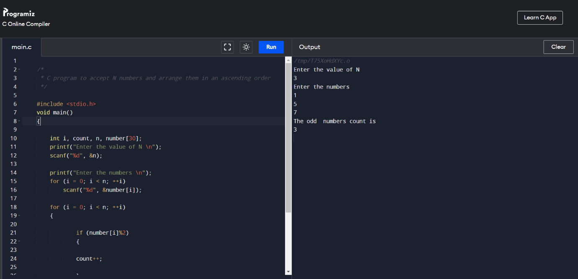

**// 7 even**

/*

* C program to accept N numbers and arrange them in an ascending order

*/

#include <stdio.h>

void main()

{

int i, count, n, number[30];

printf("Enter the value of N \n");

scanf("%d", &n);

printf("Enter the numbers \n");

for (i = 0; i < n; ++i)

scanf("%d", &number[i]);

for (i = 0; i < n; ++i)

{

if (number[i]%2)

{

continue;

}

else

count++;

}

printf("The odd numbers count is \n");

printf("%d\n", count);

}

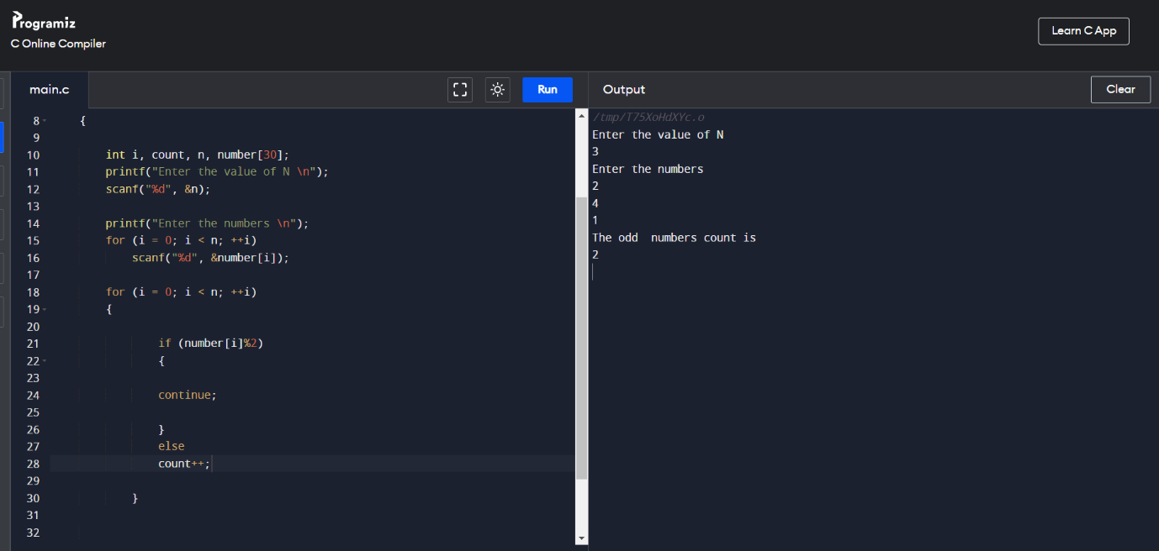

**//8* C program to accept N numbers and arrange them in an ascending order**

*/

/*

#include <stdio.h>

void main()

{

int i, n;

printf("Enter the value of N \n");

scanf("%d", &n);

int number[n],countt[n];

printf("Enter the numbers \n");

for (i = 0; i < n; ++i)

scanf("%d", &number[i]);

for (i = 0; i < n; i++)

{

int remainder,res=0,j;

int count=0;

for(j=0;number[i]!='\0';j++)

{

remainder =number[i]%10;

count++;

number[i]=number[i]/10;

}

countt[i]=count;

}

for (i = 0; i < n; ++i)

printf("\nDigits of number at index %d is : %d ",i,countt[i]);

}

**// 9Addition of digits**

/*

* C program to accept N numbers and arrange them in an ascending order

*/

#include <stdio.h>

void main()

{

int i, n,sum;

printf("Enter the value of N \n");

scanf("%d", &n);

int number[n],countt[n];

printf("Enter the numbers \n");

for (i = 0; i < n; ++i)

scanf("%d", &number[i]);

for (i = 0; i < n; i++)

{

int remainder,res=0,j;

int count=0;

for(j=0;number[i]!='\0';j++)

{

remainder =number[i]%10;

sum=sum+remainder;

number[i]=number[i]/10;

}

countt[i]=sum;

sum=0;

}

for (i = 0; i < n; ++i)

printf("\nsum of Digits of number at index %d is : %d ",i,countt[i]);

}

..

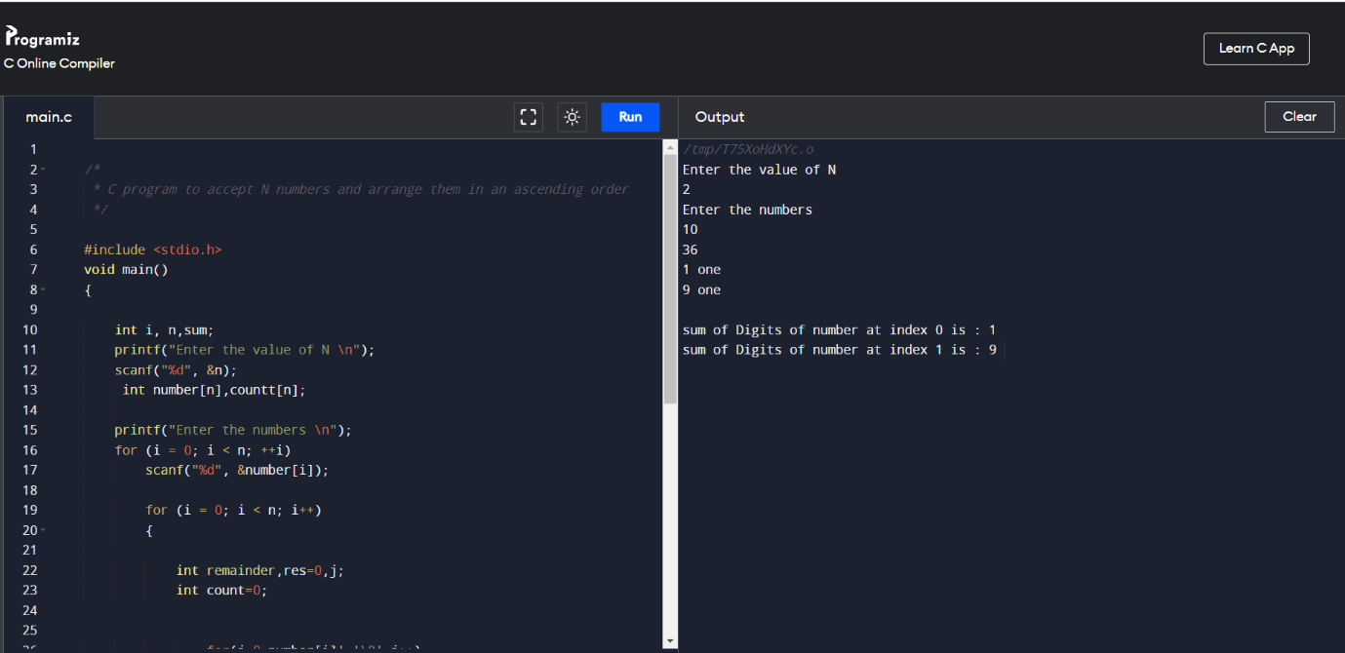

**//10 function to check number is prime or not**

#include <stdio.h>

//function to check number is prime or not

//function will return 1 if number is prime

int isPrime(int num)

{

int i; //loop counter

//it will be 1 when number is not prime

int flag=0;

//loop to check number is prime or not

//we will check, if number is divisible

//by any number from 2 to num/2, then it

//will not be prime

for(i=2; i<num/2; i++)

{

if(num%i ==0)

{

flag =1;

break;

}

}

//flag is 1, if number is not prime

if(flag==1)

return 0;

else

return 1;

}

int main()

{

int loop; //loop counter

//declaring array with prime and not prime numbers

int arr[]={100, 200, 31, 13, 97, 10, 20, 11};

//calculate length of the array

int len = sizeof(arr)/sizeof(arr[0]);

//print array elements with message

//"prime" or "Not prime"

for(loop=0; loop<len; loop++)

{

printf("%3d - %s\n",arr[loop],(isPrime(arr[loop])?"Prime":"Not Prime"));

}

printf("\n");

return 0;

}

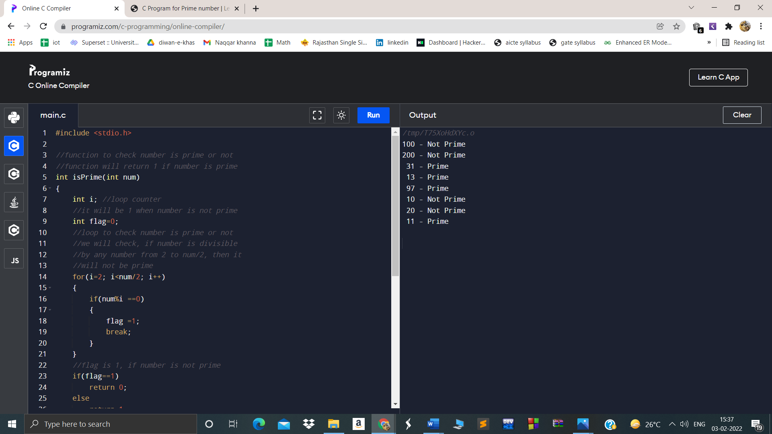

//11 prgm to check if a number is prime or not

#include <stdio.h>

//function to check number is prime or not

//function will return 1 if number is prime

int isPrime(int num)

{

int i;

int prime=0;//loop counter

//it will be 1 when number is not prime

int flag=0;

//loop to check number is prime or not

//we will check, if number is divisible

//by any number from 2 to num/2, then it

//will not be prime

for(i=2; i<num/2; i++)

{

if(num%i ==0)

{

flag =1;

prime++;

break;

}

else

{

continue;

}

}

//flag is 1, if number is not prime

if(flag==1)

{return 0;

return prime;}

else

return 1;

}

int main()

{

int loop; //loop counter

//declaring array with prime and not prime numbers

int arr[]={2, 200, 31, 13, 97, 10, 20, 11};

//calculate length of the array

int len = sizeof(arr)/sizeof(arr[0]);

//print array elements with message

//"prime" or "Not prime"

for(loop=0; loop<len; loop++)

{

printf("%3d - %s\n",arr[loop],(isPrime(arr[loop])?"Prime":"Not Prime"));

}

printf("total count of prime is 5\n");

return 0;

}

